**NETHERLANDS DIAGNOSTIC TOOLS MARKET**

According to Intelli, the Netherlands Diagnostic Tools Market was valued at USD 2,550 million in 2024 and is projected to reach USD 3505.72 million by 2032, growing at a CAGR of 4.96% during the forecast period.

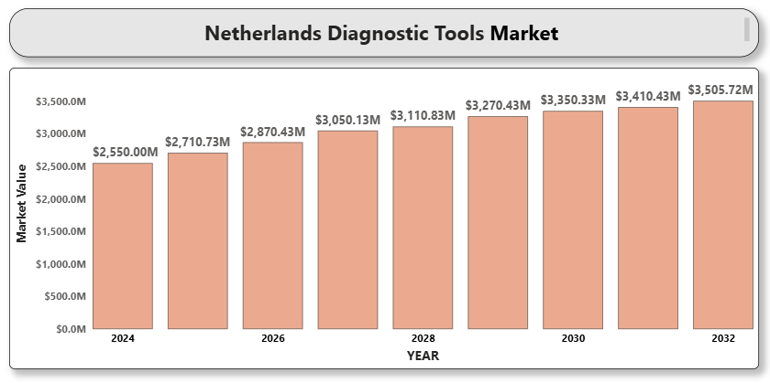

The Dutch healthcare system is known for its efficiency, digitization, and preventive care initiatives, which are key drivers of diagnostic tools adoption. Investments in modernizing diagnostic laboratories and integrating digital health records have increased the demand for high-throughput, connected diagnostic systems. Additionally, a rising elderly population, along with a growing burden of chronic diseases such as cancer, cardiovascular diseases, and diabetes, is fueling the need for early diagnosis and regular monitoring.

**Netherlands Diagnostic Tools Market Definition**

Diagnostic tools refer to a wide array of instruments, devices, kits, and techniques used for detecting, diagnosing, and monitoring diseases or medical conditions. These include imaging systems, in-vitro diagnostics (IVD), point-of-care testing devices, molecular diagnostics, and digital diagnostic solutions.

In the Netherlands, diagnostic tools are pivotal in both clinical and research settings, enabling healthcare providers to deliver timely and accurate diagnoses. The market includes a mix of traditional laboratory testing and advanced diagnostic methods such as AI-enabled imaging, genetic testing, and portable diagnostics used across hospitals, laboratories, clinics, and home-care environments.

**Netherlands Diagnostic Tools Market Overview**

The COVID-19 pandemic accelerated the uptake of point-of-care and home diagnostic tools, creating a more decentralized testing landscape. The post-pandemic phase continues to favor portable, real-time diagnostics integrated with cloud-based data platforms. Furthermore, collaborations between diagnostic companies, research institutions, and healthcare providers in the Netherlands are fostering innovation in molecular and genetic diagnostics.

The country’s proactive stance on healthcare digitization, government support for health technology innovation, and rising patient awareness are anticipated to further drive growth in the diagnostic tools market.

**Netherlands Diagnostic Tools Market Segment Analysis**

**By Product Type**

* **In-Vitro Diagnostics (IVD):** Includes reagents, analyzers, and test kits for clinical chemistry, immunoassays, and hematology; widely used in hospital and clinical labs.
* **Imaging Diagnostic Tools:** MRI, CT, ultrasound, and X-ray systems used in hospitals for radiological imaging and disease detection.
* **Point-of-Care Testing Devices:** Portable diagnostics for home and emergency care settings, crucial for chronic disease monitoring.
* **Molecular Diagnostic Tools:** Enable detection of genetic and infectious diseases through DNA/RNA analysis.
* **Others (Wearable & AI-Enabled Devices):** Emerging segment for remote health monitoring and predictive diagnostics.

**By Application**

* **Oncology:** Rising prevalence of cancer is boosting demand for biopsy-based and imaging diagnostics.
* **Cardiology:** ECGs, stress tests, and cardiac imaging play a critical role in early cardiac disease detection.
* **Infectious Diseases:** PCR and rapid antigen tests remain essential tools, especially in post-pandemic scenarios.
* **A close-up of hands holding a tablet and a pen

  Description automatically generatedDiabetes:** Blood glucose monitors and HbA1c tests form a large part of routine diagnostics.
* **Others (Genetic Disorders, Autoimmune, etc.):** Niche but rapidly growing segment.

**By End User**

* **Hospitals & Clinics:** Major adopters of both imaging and lab-based diagnostics.
* **Diagnostic Laboratories:** Use high-throughput systems for population-scale testing.
* **Home Care Settings:** Increasing demand for self-monitoring and telehealth-integrated tools.
* **Academic & Research Institutes:** Focus on biomarker discovery, test development, and clinical validation.

**Netherlands Diagnostic Tools market Competitive Landscape**

The Netherlands Diagnostic Tools Market is moderately fragmented with a strong presence of multinational players and local startups. Companies are focused on digital integration, regulatory compliance, and product differentiation to gain market share.

**Key Profiles of Netherlands Diagnostic Tools market**

* Roche Diagnostics
* Siemens Healthineers
* Abbott Laboratories
* Thermo Fisher Scientific
* GE Healthcare
* Philips Healthcare (Headquartered in the Netherlands)
* Bio-Rad Laboratories
* Beckman Coulter (Danaher Corporation)
* QIAGEN
* A close-up of hands holding a tablet and a pen

  Description automatically generatedMedtronic
* HemoCue AB
* Nova Biomedical

**Key Developments**

* **On December 1, 2024**, Royal Philips unveiled its latest AI-powered diagnostic and treatment imaging innovations aimed at improving workflow efficiency and precision in radiology. These advancements, supported by cloud-based data management, automation, and AI, seek to reduce administrative burdens and enhance clinical decision-making.
* **On September 30, 2024**, QIAGEN announced the launch of the QIAcuityDx Digital PCR System, marking a significant expansion of its digital PCR portfolio into clinical diagnostics.

**Market Attractiveness**

The Netherlands is an attractive market for diagnostic tools due to its universal healthcare system, tech-savvy population, and strong public-private research ecosystem. The push for early diagnostics, patient-centric healthcare, and digital health solutions enhances market growth prospects.

**Porter’s Five Forces Analysis**

* **Threat of New Entrants:** Moderate, given the need for technical expertise and regulatory clearance.
* **Bargaining Power of Suppliers:** Moderate, especially in proprietary technology areas.
* **Bargaining Power of Buyers:** High, with hospitals and labs demanding accuracy, speed, and cost-efficiency.
* **A close-up of hands holding a tablet and a pen

  Description automatically generatedThreat of Substitutes:** Low, as diagnostic accuracy remains irreplaceable.
* **Competitive Rivalry:** High, with global and regional players actively innovating.

**Table of Contents**

1. **Introduction of Netherlands Diagnostic Tools Market**
   * 1.1 Overview of the Market
   * 1.2 Scope of Report
   * 1.3 Assumptions
2. **Executive Summary**
3. **Research Methodology**
   * 3.1 Data Mining
   * 3.2 Validation
   * 3.3 Primary Interviews
   * 3.4 List of Data Sources
4. **Netherlands Diagnostic Tools Market Outlook**
   * 4.1 Market Definition
   * 4.2 Market Overview
   * 4.3 Porter’s Five Forces Model
   * 4.4 Value Chain Analysis
5. **Market, by Product Type**
   * 5.1 In-Vitro Diagnostics
   * 5.2 Imaging Diagnostic Tools
   * 5.3 Point-of-Care Testing Devices
   * 5.4 Molecular Diagnostic Tools
   * 5.5 Others
6. **Market, by Application**
   * 6.1 Oncology
   * 6.2 Cardiology
   * 6.3 Infectious Diseases
   * 6.4 Diabetes
   * 6.5 Others
7. **Market, by End User**
   * 7.1 Hospitals & ClinicsA close-up of hands holding a tablet and a pen

     Description automatically generated
   * 7.2 Diagnostic Laboratories
   * 7.3 Home Care Settings
   * 7.4 Academic & Research Institutes
8. **Competitive Landscape**
   * Overview
   * Company Market Rankin
   * A close-up of hands holding a tablet and a pen

     Description automatically generatedKey Development Strategies
9. **Company Profiles**

**9.1 Roche Diagnostics**

* 9.1.1 Overview
* 9.1.2 Financial Performance
* 9.1.3 Product Outlook
* 9.1.4 Key Developments

**9.2 Siemens Healthineers**

* 9.2.1 Overview
* 9.2.2 Financial Performance
* 9.2.3 Product Outlook
* 9.2.4 Key Developments

**9.3 Abbott Laboratories**

* 9.3.1 Overview
* 9.3.2 Financial Performance
* 9.3.3 Product Outlook
* 9.3.4 Key Developments

**9.4 Thermo Fisher Scientific**

* 9.4.1 Overview
* 9.4.2 Financial Performance
* 9.4.3 Product Outlook
* 9.4.4 Key Developments

**9.5 GE Healthcare**

* A close-up of hands holding a tablet and a pen

  Description automatically generated9.5.1 Overview
* 9.5.2 Financial Performance
* 9.5.3 Product Outlook
* 9.5.4 Key Developments

**9.6 Philips Healthcare (Netherlands)**

* 9.6.1 Overview
* 9.6.2 Financial Performance
* 9.6.3 Product Outlook
* 9.6.4 Key Developments

**9.7 Bio-Rad Laboratories**

* 9.7.1 Overview
* 9.7.2 Financial Performance
* 9.7.3 Product Outlook
* 9.7.4 Key Developments

**9.8 Beckman Coulter (Danaher Corporation)**

* 9.8.1 Overview
* 9.8.2 Financial Performance
* 9.8.3 Product Outlook
* 9.8.4 Key Developments

**9.9 QIAGEN**

* 9.9.1 Overview
* 9.9.2 Financial Performance
* 9.9.3 Product Outlook
* 9.9.4 Key Developments

**9.10 Medtronic**

* 9.10.1 Overview
* 9.10.2 Financial Performance
* 9.10.3 Product Outlook
* 9.10.4 Key Developments

**9.11 HemoCue AB**

* 9.11.1 Overview
* 9.11.2 Financial Performance
* 9.11.3 Product Outlook
* 9.11.4 Key Developments

**9.12 Nova Biomedical**

* 9.12.1 Overview
* 9.12.2 Financial Performance
* 9.12.3 Product Outlook
* 9.12.4 Key Developments

1. **Key Developments**

* Product Launches/Developments
* Mergers and Acquisitions
* Business Expansions

1. **Appendix**

* 11.1 Related Research